**POST APPLIED FOR : ACCOUNTS CUM ADMIN OFFICER .**

**CURRICLUM VITAE**

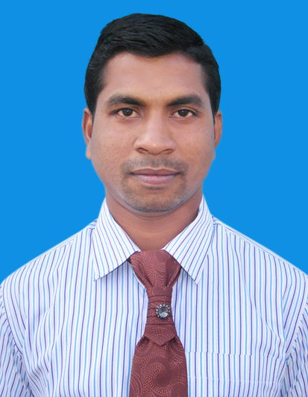

# PARESH KUMAR JENA

**C/O: Srikanta Prusty ,**

**At: Chauliaganja (Matha Sahi),**

**Po: Nayabazar,**

**Dist: Cuttack (Odisha),**

**Pin – 753004**

**Mob No: 7894515134, 9861809264**

**Email ID: jenaparesh8@gmail.com**

# Career Objective

* **To be part of a constructive and productive and contribute significantly to the same.**

**Educational Qualification**

* + **H.S.C. from B.S.E., Orissa in 2003.**
  + **I.Com from Cuttack College, Cuttack, CHSE, Orissa, in 2005.**
  + **B.Com from Cuttack College, Cuttack, Utkal University in 2008.**

Professional Qualification & Computer Skills

* **PGDCA Course Completed from Soft-ed Institute, Cuttack.**
* **Completed Corporate Accounts Professional from Institute of Management & Professional Accounts Training (IMPACT), Cuttack.**

**It consists of :**

**Module I : DOS, MS Office (Word, Excel, Powerpoint & Internet).**

**Module II : Accounting Packages (Tally ERP9.0, WINGS).**

**WORK EXPERIENCE**

* **I have worked as Computer Operator from June 2009 to Feb 2012 in CAPITAL AGENCIES at Cuttack.**
* **I have worked as Billing Assistant from March 2012 to July 2014 in KYAL AGENCIES at Cuttack.**
* **I have worked as Data Entry Officer from September 2014 to Dec 2016 in HINDUSTAN LATEX FAMILY PLANNING PROMOTION TRUST (HLFPPT) at Bhubaneswar.**
* **Now I am working as Accounts Assistant from Dec 2016 to till date as in SIKA INDIA PRIVATE LIMITED (SIPL) at Bhubaneswar.**

**Personal Traits:**

**Healthy, Positive, responsible, & good communication skill.**

**Personal Details:**

# NAME : PARESH KUMAR JENA

**Father’s Name : Mr. Bijaya Kumar Jena**

**Date of Birth : 19th June 1987**

**Nationality : Indian**

**Religion : Hindu**

**Marital Status : Un-Married**

**Sex : Male**

**Category : GENERAL (UR)**

**Languages Known : Oriya, English and Hindi, (Read, Write & Speak)**

## **Declaration**

**I do hereby declare that the above mentioned particulars are true and correct to the best of my knowledge and belief.**

**DATE: 31.03-2020**

**PLACE: CUTTACK (PARESH KUMAR JENA)**